**Project 1: Adding Storage Devices**

*In this Hands-On Project, you add four virtual hard disks to your WindowsServer2019VM2 virtual machine. You will configure volumes on these virtual hard disks in Hands-On Projects 2, 3, and 4.*

1. Boot your Windows Server 2019 host and log into the system as Administrator using the password **Secret555**. Next, click **Start** and then click **Server Manager**.
2. In Server Manager, select the **Tools** menu and then click **Hyper-V Manager**.
3. In Hyper-V Manager, highlight **WindowsServer2019VM2** in the Virtual Machines pane and click **Settings** in the Actions pane.
4. Highlight **SCSI Controller** under the Hardware section. Click **Add** to add an additional hard drive. Next, click **New** to create a new virtual hard disk file for this additional hard drive.
5. At the Before You Begin page of the New Virtual Hard Disk Wizard, click **Next**.
6. On the Choose Disk Format page, note that VHDX is selected by default and click **Next.**
7. On the Choose Disk Type page, note that Dynamically expanding is selected by default and click **Next**.
8. On the Specify Name and Location page, type **Disk1.vhdx** in the Name text box and click **Next**.
9. On the Configure Disk page, type **50** in the Size text box and click **Next**.
10. Click **Finish** to create the new virtual hard disk file and associate it with your new SCSI virtual hard disk.
11. Highlight **SCSI Controller** under the Hardware section. Click **Add** to add an additional hard drive. Next, click **New** to create a new virtual hard disk file for this additional hard drive.
12. At the Before You Begin page of the New Virtual Hard Disk Wizard, click **Next**.
13. On the Choose Disk Format page, note that VHDX is selected by default and click **Next**.
14. On the Choose Disk Type page, note that Dynamically expanding is selected by default and click **Next**.
15. On the Specify Name and Location page, type **Disk2.vhdx** in the Name text box and click **Next**.
16. On the Configure Disk page, type **50** in the Size text box and click **Next**.
17. Click **Finish** to create the new virtual hard disk file and associate it with your new SCSI virtual hard disk.
18. Highlight **SCSI Controller** under the Hardware section. Click **Add** to add an additional hard drive. Next, click **New** to create a new virtual hard disk file for this additional hard drive.
19. At the Before You Begin page of the New Virtual Hard Disk Wizard, click **Next**.
20. On the Choose Disk Format page, note that VHDX is selected by default and click **Next**.
21. On the Choose Disk Type page, note that Dynamically expanding is selected by default and click **Next**.
22. On the Specify Name and Location page, type **Disk3.vhdx** in the Name text box and click **Next**.
23. On the Configure Disk page, type **50** in the Size text box and click **Next.**
24. Click **Finish** to create the new virtual hard disk file and associate it with your new SCSI virtual hard disk.
25. Highlight **SCSI Controller** under the Hardware section. Click **Add** to add an additional hard drive. Next, click **New** to create a new virtual hard disk file for this additional hard drive.
26. At the Before You Begin page of the New Virtual Hard Disk Wizard, click **Next**.
27. On the Choose Disk Format page, note that VHDX is selected by default and click **Next**.
28. On the Choose Disk Type page, note that Dynamically expanding is selected by default and click **Next**.
29. On the Specify Name and Location page, type **Disk4.vhdx** in the Name text box and click **Next**.
30. On the Configure Disk page, type **50** in the Size text box and click **Next**.
31. Click **Finish** to create the new virtual hard disk file and associate it with your new SCSI virtual hard disk.

**(Take Screenshot)**

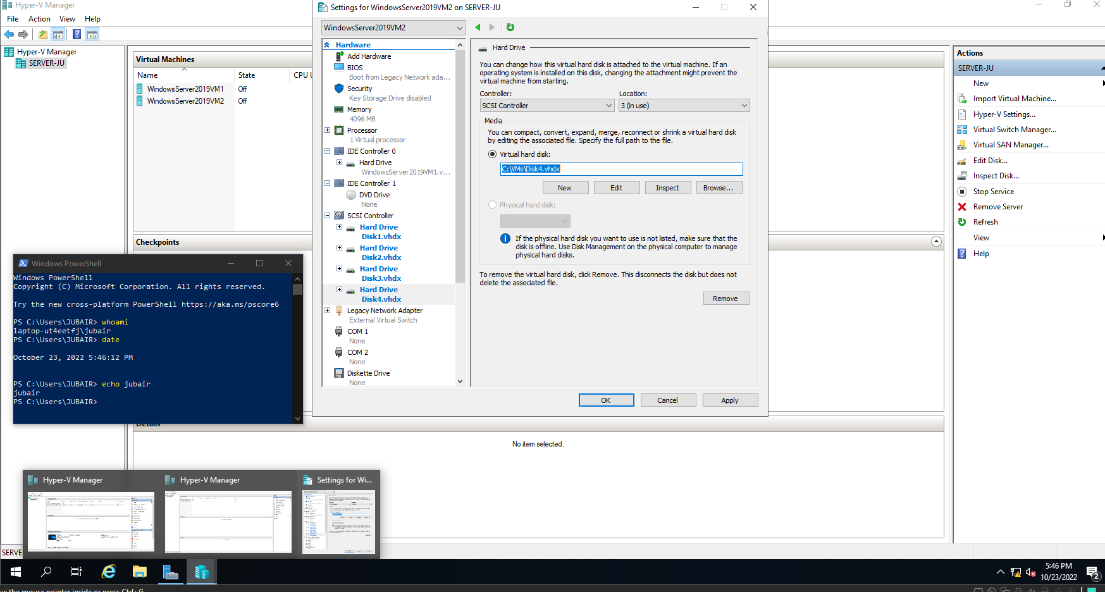

1. Click **OK** to close the Settings window for your WindowsServer2019VM2 virtual machine.
2. Highlight **WindowsServer2019VM2** in the virtual machines pane of Hyper-V Manager and click **Connect** in the Actions pane. In the Virtual Machine Connection window, click **Start** to boot your new virtual machine.
3. At the login screen, click the **Ctrl+Alt+Delete** button in the Virtual Machine Connection window, supply the password **Secret555** for Administrator and press **Enter** to log into the system.

**Project 2: Disk Management (Simple Volumes)**

*In this Hands-On Project, you use the Disk Management tool to configure and manage simple volumes on the first virtual hard disk that you added to your WindowsServer2019VM2 virtual machine in Hands-On Project 1.*

1. On your WindowsServer2019VM2 virtual machine, right-click **Start** and then click **Disk** **Management**. In the Disk Management tool, view your disk, partition, and volume configuration:

* The first disk (Disk 0) is a basic disk that contains two primary partitions:
* A 549 MB NTFS recovery partition that is marked active. This partition is labeled the system partition as it also contains the boot loader.
* An NTFS partition that uses the remaining available space. This partition is labeled the boot partition as it contains the Windows operating system and is identified as the C: volume.
* The remaining disks (Disk 1, Disk 2, Disk 3, and Disk 4) are in an Offline state and do not contain any partitions.

1. Right-click **Disk 1** and click **Online**. Next, right-click **Disk 2** and click **Online**, then right-click **Disk 3** and click **Online**. Note that Disk 1, Disk 2, and Disk 3 are labeled as Not Initialized to indicate that they do not have a partition table (either MBR or GPT).
2. Right-click **Disk 1** and click **Initialize Disk**. Note the default options that will place an MBR on Disk 1, Disk 2, and Disk 3, and click **OK**. Note that Disk 1, Disk 2, and Disk 3 are labeled as Basic to indicate that they are now recognized as basic disks in Windows Server 2019.
3. Right-click the **50.00 GB Unallocated** space next to Disk 1 and click **New Simple Volume**.
4. At the New Simple Volume wizard, click **Next**.
5. At the Specify Volume Size page, type **5000** in the *Simple volume size in MB* text box and click **Next**.
6. At the Assign Drive Letter or Path page, note the default E: drive letter assignment and click **Next**. The D: drive letter is reserved for use by the virtual DVD drive in WindowsServer2019VM2.
7. At the Format Partition page, note the default NTFS formatting options, type **Simple Volume 1** in the Volume label text box, and click **Next**.
8. Click **Finish** to complete your configuration. Note that your E: volume is associated with the first primary partition on Disk 1. Also note volume size of 5000 MB (4.88 GB).
9. Right-click the **45.12 GB Unallocated** space next to Disk 1 and click **New Simple Volume**.
10. At the New Simple Volume wizard, click **Next**.
11. At the Specify Volume Size page, type **5000** in the Simple volume size in MB text box and click **Next**.
12. At the Assign Drive Letter or Path page, note the default F: drive letter assignment and click **Next**.
13. At the Format Partition page, note the default NTFS formatting options, type **Simple Volume 2** in the Volume label text box, and click **Next**.
14. Click **Finish** to complete your configuration. Note that your 4.88 GB F: volume is associated with the second primary partition on Disk 1.
15. Right-click the **40.23 GB Unallocated** space next to Disk 1 and click **New Simple Volume**.
16. At the New Simple Volume wizard, click **Next**.
17. At the Specify Volume Size page, type **5000** in the *Simple volume size in MB* text box and click **Next**.
18. At the Assign Drive Letter or Path page, note the default G: drive letter assignment and click **Next**.
19. At the Format Partition page, note the default NTFS formatting options, type **Simple Volume 3** in the Volume label text box, and click **Next**.
20. Click **Finish** to complete your configuration. Note that your 4.88 GB G: volume is associated with the third primary partition on Disk 1.
21. Right-click the **35.35 GB Unallocated** space next to Disk 1 and click **New Simple Volume**.
22. At the New Simple Volume wizard, click **Next.**
23. At the Specify Volume Size page, type **5000** in the Simple volume size in MB text box and click **Next.**
24. At the Assign Drive Letter or Path page, note the default H: drive letter assignment and click **Next**.
25. At the Format Partition page, note the default NTFS formatting options, type **Simple Volume 4** in the Volume label text box, and click **Next**.
26. Click **Finish** to complete your configuration. Note that your 4.88 GB H: volume is associated with the first logical drive in an extended partition that was created from the remaining space on Disk 1.
27. Right-click the **30.47 GB Free space** in the extended partition on Disk 1 and click **New Simple Volume.**
28. At the New Simple Volume wizard, click **Next**.
29. At the Specify Volume Size page, note the default value that uses the remaining available space and click **Next.**
30. At the Assign Drive Letter or Path page, select **Mount in the following empty NTFS folder** and click **Browse**. Click **New Folder**, type **Data**, and press **Enter** to create a new folder called Data on C:\. Click **OK**, note that the new volume will be accessible via the C:\Data folder, and click **Next**.
31. At the Format Partition page, note the default NTFS formatting options, type **Simple Volume 5** in the Volume label text box, and click **Next**.
32. Click **Finish** to complete your configuration. Note that your new volume is associated with the second logical drive in the extended partition. Also note that the I: drive letter was assigned to allow you to easily manage the volume in Disk Management.

**(Take Screenshot)**

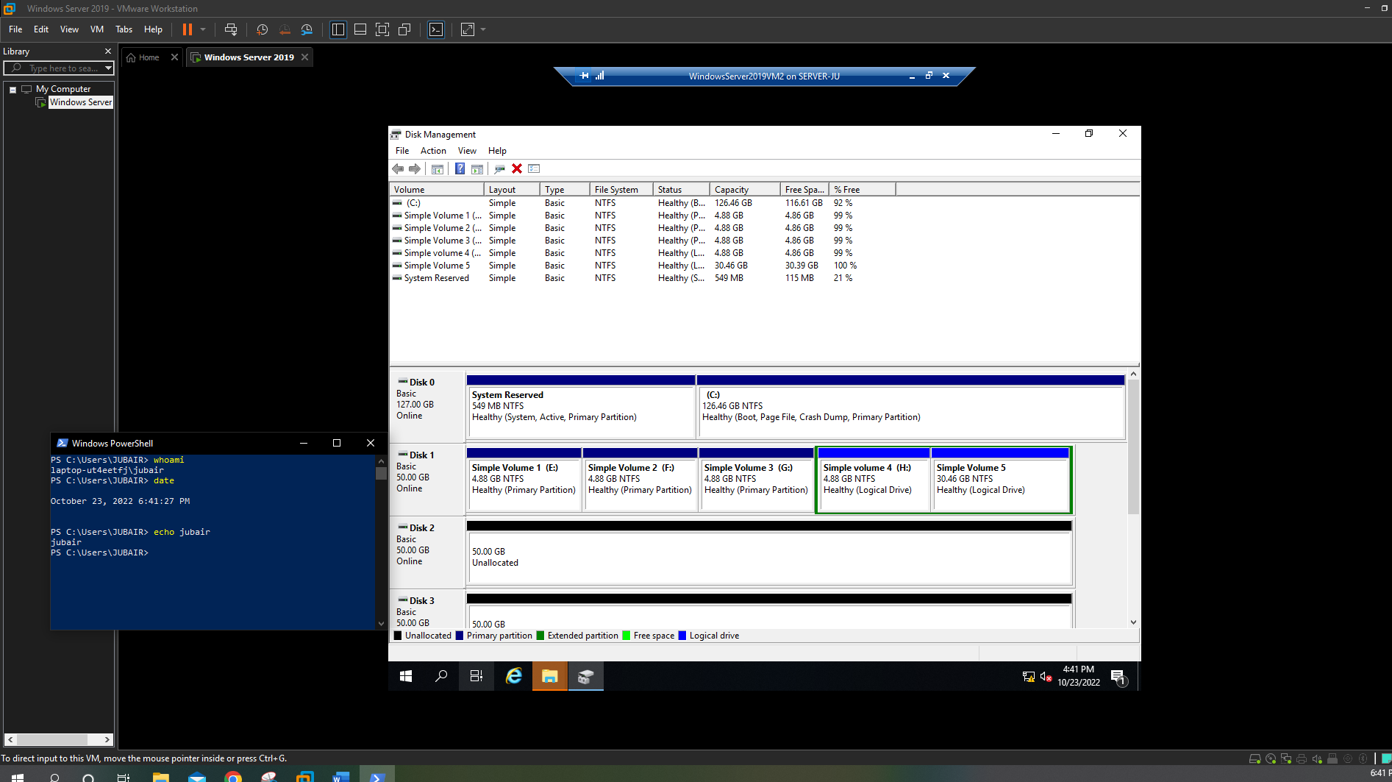

1. Click **Start** and then click **File Explorer**.
2. In File Explorer, highlight **This PC** in the navigation pane and note the volume drive letters available and their associated labels.
3. Double-click **Local Disk (C:)** and note that the C:\Data folder is assigned a hard disk icon and has a size defined in the File Explorer window.
4. Double-click **C:\Data** to access the NTFS filesystem in the second logical drive on Disk1.
5. Close File Explorer.
6. In the Disk Management tool, right-click **Simple Volume 5 (I:)** and click **Shrink Volume**. Type **10000** in the Enter the amount of space to shrink in MB text box and click **Shrink**. Note that 9.77 GB of free space was made available in the extended partition.
7. Right-click **Simple Volume 5 (I:),** click **Delete Volume**, and then click **Yes** to remove Simple Volume 5.
8. Right-click **Simple Volume 4 (H:),** click **Delete Volume**, and then click **Yes** to remove Simple Volume 4.
9. Right-click the extended partition on Disk 1 **(35.35 GB Free space**), click **Delete** **Partition**, and then click **Yes** to remove the extended partition.
10. Right-click **Simple Volume 3 (G:),** click **Delete Volume**, and then click **Yes** to remove Simple Volume 3.
11. Right-click **Simple Volume 2 (F:),** click **Delete Volume**, and then click **Yes** to remove Simple Volume 2.
12. Right-click **Simple Volume 1 (E:)** and click **Extend Volume**.
13. At the Extend Volume Wizard, click **Next**.
14. At the Select Disks page, note that the remaining free space on Disk 1 is selected by default and click **Next**.
15. Click **Finish** to extend Simple Volume 1. Note that Simple Volume 1 now uses all of the 50 GB of available space on Disk 1.
16. Click **Start** and then click **File Explorer**.
17. In File Explorer, highlight **This PC** in the navigation pane and note that only the C: and E: volumes are available.
18. Double-click **Local Disk (C:)** and then double-click the C:\Data folder. Note the error that you receive and click **OK**.
19. Close File Explorer.
20. In the Disk Management tool, right-click **Simple Volume 1 (E:),** click **Delete Volume**, and then click **Yes** to remove Simple Volume 1.

**Project 3: Disk Management (RAID)**

*In this Hands-On Project, you configure and manage RAID volumes on the virtual hard disks that you added to your WindowsServer2019VM2 virtual machine in Hands-On Project 1.*

1. In the Disk Management tool on WindowsServer2019VM2, right-click **Disk 1** and click **New Spanned Volume.**
2. At the New Spanned Volume wizard, click **Next**.
3. At the Select Disks page, note that Disk 1 is selected by default. Select **Disk 2** and click **Add**. Click **Add** again to add the remaining disk (Disk 3). Note that the Total volume size in megabytes (MB) lists the combined space available on all three hard disks (153591) and click **Next.**
4. At the Assign Drive Letter or Path page, note the default E: drive letter assignment and click **Next**.
5. At the Format Partition page, note the default NTFS formatting options, type **Spanned Volume 1** in the Volume label text box, select **Perform a quick format**, and click **Next**.
6. Click **Finish.** Click **Yes** when prompted that the operation will convert your disks to dynamic disks. Note that Spanned Volume 1 (E:) is composed of all available space on Disk 1, Disk 2, and Disk 3. Also note that Disk 1, Disk 2, and Disk 3 are assigned a Dynamic disk label.
7. Click **Start** and then click **File Explorer**.
8. In File Explorer, highlight **This PC** in the navigation pane and note that the Spanned Volume 1 (E:) uses the combined space available on Disk 1, Disk 2, and Disk 3.
9. Close File Explorer.
10. In the Disk Management tool, right-click **Spanned Volume 1 (E:),** click **Delete Volume**, and then click **Yes** to remove Spanned Volume 1. Note that Disk 1, Disk 2, and Disk 3 are assigned a Basic disk label.
11. In the Disk Management tool, right-click **Disk 1** and click **New Striped Volume**.
12. At the New Striped Volume wizard, click **Next.**
13. At the Select Disks page, note that Disk 1 is selected by default. Select **Disk 2** and click **Add**. Click **Add** again to add the remaining disk (Disk 3). Note that the Total volume size in megabytes (MB) lists the combined space available on all three hard disks (153591) and click **Next**.
14. At the Assign Drive Letter or Path page, note the default E: drive letter assignment and click **Next**.
15. At the Format Partition page, note the default NTFS formatting options, type **Striped Volume 1** in the Volume label text box, select **Perform a quick format**, and click **Next**.
16. Click **Finish**. Click **Yes** when prompted that the operation will convert your disks to dynamic disks. Note that Striped Volume 1 (E:) is composed of all available space on Disk 1, Disk 2, and Disk 3.
17. Click **Start** and then click **File Explorer**.
18. In File Explorer, highlight **This PC** in the navigation pane and note that the Striped Volume 1 (E:) uses the combined space available on Disk 1, Disk 2, and Disk 3.
19. Close File Explorer.
20. In the Disk Management tool, right-click **Striped Volume 1 (E:),** click **Delete Volume**, and then click **Yes** to remove Striped Volume 1. Note that Disk 1, Disk 2, and Disk 3 are assigned a Basic disk label.
21. In the Disk Management tool, right-click **Disk 1** and click **New Mirrored Volume**.
22. At the New Mirrored Volume wizard, click **Next**.
23. At the Select Disks page, note that Disk 1 is selected by default. Select **Disk 2** and click **Add**. Note that the Total volume size in megabytes (MB) lists the space available on a single hard disk (51197) and click **Next**.
24. At the Assign Drive Letter or Path page, note the default E: drive letter assignment and click **Next**.
25. At the Format Partition page, note the default NTFS formatting options, type **Mirrored Volume 1** in the Volume label text box, select **Perform a quick format,** and click **Next**.
26. Click **Finish**. Click **Yes** when prompted that the operation will convert your disks to dynamic disks. Note that Mirrored Volume 1 (E:) uses all available space on Disk 1 and Disk 2.

**(Take Screenshot)**

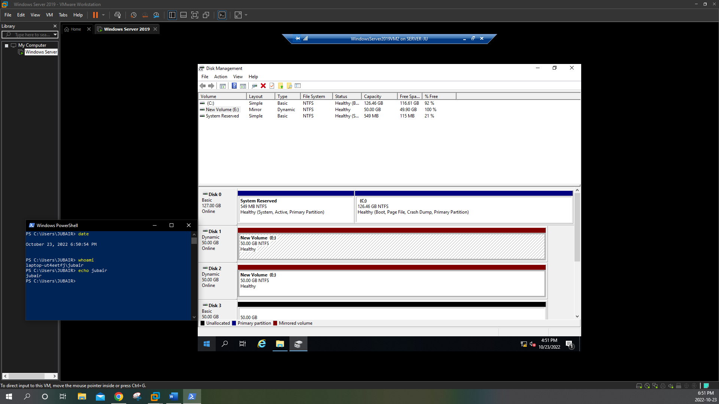

1. Click **Start** and then click **File Explorer**.
2. In File Explorer, highlight **This PC** in the navigation pane and note that the Mirrored Volume 1 (E:) lists the space available on Disk 1.
3. Close File Explorer.
4. In the Disk Management tool, right-click **Mirrored Volume 1 (E:),** click **Break Mirrored Volume**, and then click **Yes** to break the mirrored volume. Note that you now have two separate simple volumes on Disk 1 and Disk 2 (E: and F:).
5. Right-click **Mirrored Volume 1 (F:),** click **Delete Volume**, and then click **Yes** to remove the simple volume.
6. Right-click **Mirrored Volume 1 (E:)** and click **Add Mirror**. Select **Disk 3**, click **Add Mirror**, and then click **Yes** to copy the data in the Mirrored Volume 1 (E:) simple volume to Disk 3 and add a new mirror configuration.
7. Right-click **Mirrored Volume 1 (E:),** click **Delete Volume**, and then click **Yes** to remove the mirrored volume. Note that Disk 1, Disk 2, and Disk 3 are assigned a Basic disk label.
8. In the Disk Management tool, right-click **Disk 1** and click **New RAID-5 Volume**.
9. At the New RAID-5 Volume wizard, click **Next**.
10. At the Select Disks page, note that Disk 1 is selected by default. Select **Disk 2** and click **Add**. Click **Add** again to add the remaining disk (Disk 3). Note that the Total volume size in megabytes (MB) lists the combined space available on two of the three hard disks (102394) to allow for parity and click **Next**.
11. At the Assign Drive Letter or Path page, note the default E: drive letter assignment and click **Next.**
12. At the Format Partition page, note the default NTFS formatting options, type **RAID-5 Volume 1** in the Volume label text box, select **Perform a quick format**, and click **Next**.
13. Click **Finish**. Click **Yes** when prompted that the operation will convert your disks to dynamic disks. After the syncing process has completed, note that RAID-5 Volume 1 (E:) uses all available space on Disk 1, Disk 2, and Disk 3.
14. Click **Start** and then click **File Explorer**.
15. In File Explorer, highlight **This PC** in the navigation pane and note that the RAID-5 Volume 1 (E:) lists the space available on two of the three disks that make up the volume.
16. Double-click **RAID-5 Volume 1 (E:).** Next, right-click the file pane in File Explorer and click **New, Text Document** and press **Enter** to accept the default file name of New Text Document.txt.
17. Double-click **New Text Document.txt** to open it in Notepad. Type a line of your choice. Click the **File** menu and click **Save**. Close Notepad when finished.
18. In the Disk Management tool, right-click **Disk 2** and click **Offline**. Note that the status of RAID-5 Volume 1 (E:) lists Failed Redundancy.

**(Take Screenshot)**

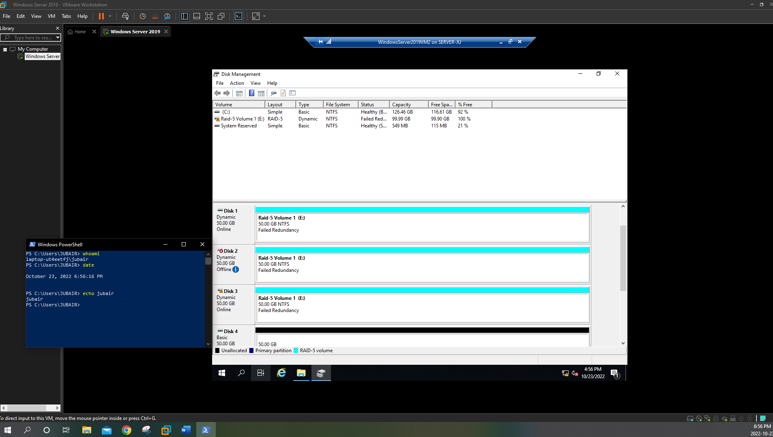

1. In File Explorer, double-click **New Text Document.txt** to open it in Notepad. Note that you have access to the file contents. Type a line of your choice. Click the **File** menu and click **Save**. Close Notepad and File Explorer when finished.
2. In the Disk Management tool, right-click **Disk 4** and click **Online.** Next, right-click **Disk 4** and click **Initialize Disk**. Note that the default option places an MBR on Disk 4 and click **OK**. Note that Disk 4 is labeled as Basic.
3. Right-click **RAID-5 Volume 1 (E:)** and click **Repair Volume**. Note that Disk 4 is selected by default, click **OK,** and then click **Yes** to generate the data on Disk 4 required to make it a functional member of the RAID-5 volume. After the process has completed, note that Disk 4 is labeled as Dynamic and part of the RAID-5 Volume 1 (E:) volume. Also note that the RAID-5 Volume 1 (E:) volume lists a Healthy status.
4. Right-click **RAID-5 Volume 1 (E:)**, click **Delete Volume**, and then click **Yes** to remove the RAID volume.
5. Right-click **Disk 2** and click **Online**. Next, right-click the partition on Disk 2, click **Delete Volume**, and then click **Yes** to remove the partition.
6. Close the Disk Management tool.

**Project 4: Server Manager and Storage Spaces**

*In this Hands-On Project, you create and manage both simple and RAID volumes in Server Manager on the virtual hard disks that you added to your WindowsServer2019VM2 virtual machine in Hands-On Project 1.*

1. On your WindowsServer2019VM2 virtual machine, click **Start** and then click **Server Manager**.
2. In Server Manager, highlight **File and Storage Services**, and then highlight Disks under the Volumes section. Note the sizes and types of disks shown in the DISKS pane that match the information shown in the Disk Management tool
3. Highlight disk number **1** in the DISKS pane, select the **TASKS** drop-down box, and click **New Volume.**
4. At the New Volume Wizard, select **Don’t show this page again** and click **Next.**
5. At the Select the server and disk page, select **Disk 1** and click **Next**.
6. At the Specify the size of the volume page, type **30** in the Volume size text box and click **Next**.
7. At the Assign to a drive letter or folder page, note the default drive letter assignment of E: and click **Next**.
8. At the Select file system settings page, note the default filesystem options, type **Simple Volume 1** in the Volume label text box, and click **Next**.
9. At the Confirm selections page, click **Create**.
10. Click **Close** to close the New Volume Wizard.
11. Highlight disk number **1** in the DISKS pane and note the E: volume in the VOLUMES pane.
12. Right-click the E: volume and click **Extend Volume**. Type **50** in the New size text box and click **OK.** After a few moments, note the new size of your E: volume.
13. Right-click the **E:** volume, click **Scan File System for Errors**, and click **Scan Now**.
14. Right-click the **E:** volume, click **Delete Volume**, and click **Yes** to remove the E: volume.
15. Highlight **Storage Pools** in the navigation pane of Server Manager and note the default Primordial pool in the STORAGE POOLS pane, and the disks listed in the PHYSICAL DISKS pane.
16. Select the **TASKS** drop-down box in the STORAGE POOLS pane and click **New Storage Pool**.
17. At the New Storage Pool Wizard, select **Don’t show this page again** and click **Next**.
18. At the Specify a storage pool name and subsystem page, type **Storage Pool 1** in the Name text box and click **Next**.
19. At the Select physical disks for the storage pool page, place checks in the boxes next to all disks and click Next.
20. At the Confirm selections page, click **Create**.
21. Click **Close** to close the New Storage Pool Wizard.
22. Highlight **Storage Pool 1** in the STORAGE POOLS pane and note the four disks shown in the PHYSICAL DISKS pane. These disks represent Disk 1, Disk 2, Disk 3, and Disk 4.
23. Highlight **Disks** in the navigation pane of Server Manager and note that only disk 0 is shown in the DISKS pane because disks 1 through 4 are now part of Storage Pool 1.
24. Highlight **Storage Pools** in the navigation pane of Server Manager.
25. Select the **TASKS** drop-down box in the VIRTUAL DISKS pane, and click **New Virtual Disk**. Ensure that Storage Pool 1 is selected and click **OK**.
26. At the New Virtual Disk Wizard, select **Don’t show this page again** and click **Next**.
27. At the Specify the virtual disk name page, type **Virtual Disk 1** in the Name text box and click **Next**.
28. At the Specify enclosure resiliency page, click **Next**.
29. At the Select the storage layout page, select **Parity** and click **Next**.
30. At the Specify the provisioning type page, select **Thin** and click **Next**.
31. At the Specify the size of the virtual disk page, type **100** in the Specify size text box and click **Next.**
32. At the Confirm selections page, click **Create**. If you receive an error at this stage, follow the instructions in the following note.
33. Click **Close** to close the New Volume Wizard.

**\*Note: There is a bug in Windows Server 2019 GUI that sometimes causes the creation of new virtual -Storagedisk to fail. If it fails for you in this lab, then you can use the following two commands to create new disk using Powershell.**

**1.** 

**2.** 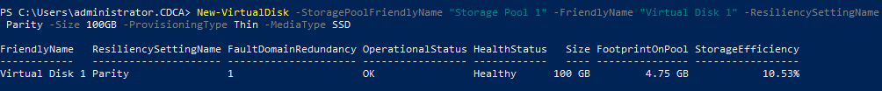

1. Click the **Refresh “Storage Pools”** icon in the navigation bar of Server Manager. Note that Virtual Disk 1 appears in the VIRTUAL DISKS pane.

**(Take Screenshot)**

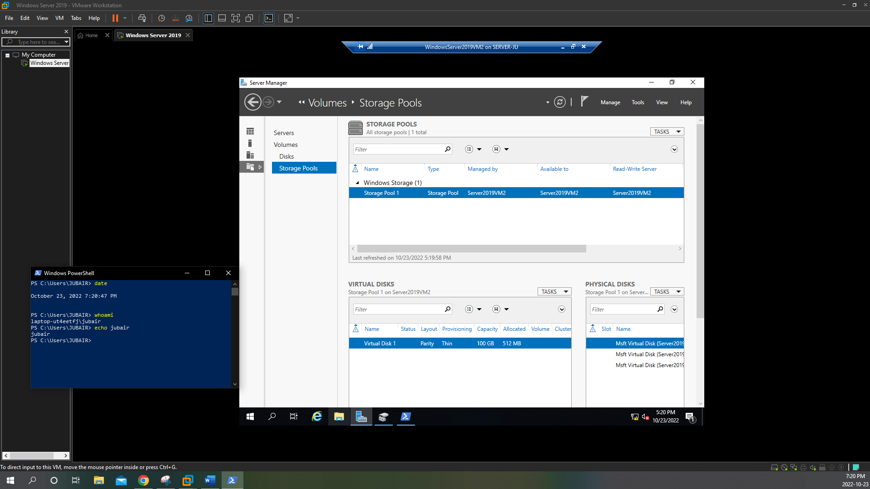

1. Highlight **Disks** in the navigation pane of Server Manager and note that Virtual Disk 1 is set to an Offline state. Right-click **Virtual Disk 1**, click **Bring Online**, and then click **Yes**.
2. Highlight **Storage Pools** in the navigation pane of Server Manager. Next, right-click **Virtual Disk 1** in the VIRTUAL DISKS pane and click **New Volume**.
3. At the Select the server and disk page of the New Volume Wizard, note that Virtual Disk 1 is selected by default and click **Next.** Click **OK** to initialize Virtual Disk 1 with a GPT.
4. At the Specify the size of the volume page, note the default size of 100 MB and click **Next**.
5. At the Assign to a drive letter or folder page, note the default drive letter assignment of E: and click **Next**.
6. At the Select file system settings page, select **ReFS** from the File system drop-down box, type **Storage Space 1** in the Volume label text box, and click **Next.**
7. At the Confirm selections page, click **Create**.

**(Take Screenshot)**

**\**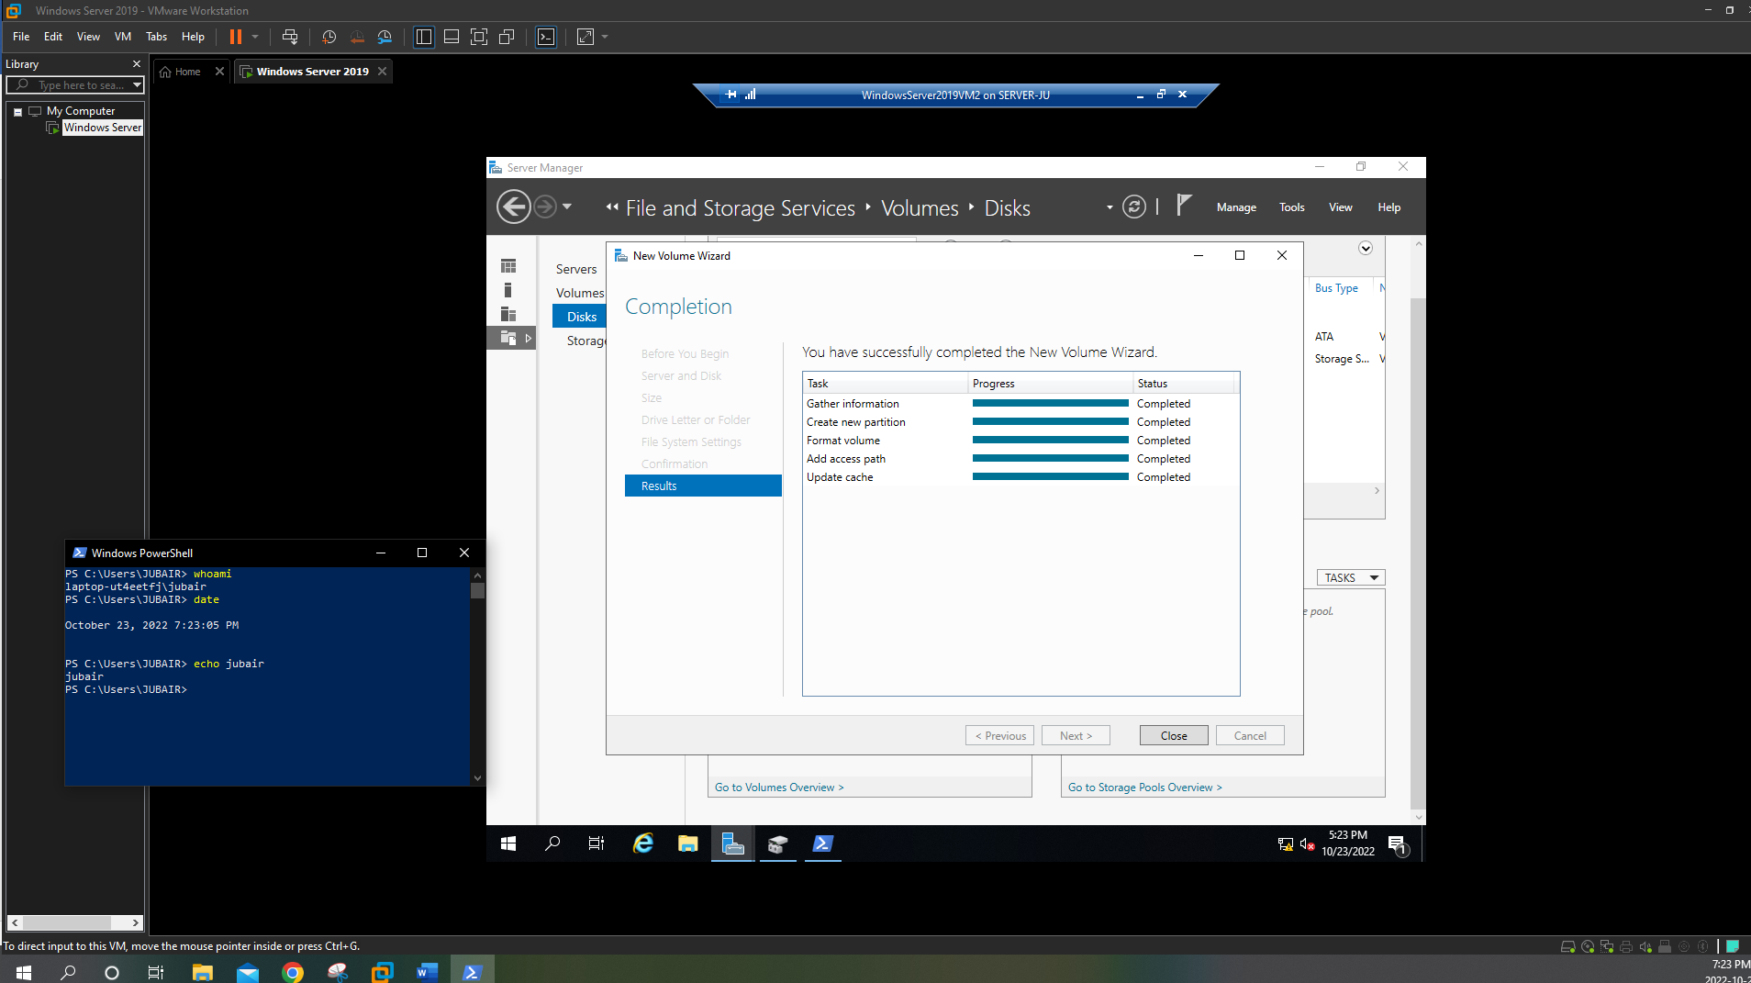

1. Click **Close** to close the New Volume Wizard.
2. Click **Start** and then click **File Explorer**. In File Explorer, highlight **This PC** in the navigation pane and note that Storage Space 1 (E:) lists the space available from the virtual disk created from the storage pool. Close File Explorer when finished.

**Project 5: iSCSI Target Server**

*In this Hands-On Project, you install and configure the iSCSI Target Server on your WindowsServer2019VM2 virtual machine to provide iSCSI storage to your Windows Server 2019 host. Next, you configure the iSCSI Initiator on your Windows Server 2019 host to connect to the iSCSI storage, as well as create a simple volume in Disk Management to access it.*

1. In Server Manager on your WindowsServer2019VM2 virtual machine, click the **Manage** menu and then click **Add Roles and Features**.
2. At the Select installation type page, click **Next**.
3. At the Select destination server page, click **Next**.
4. At the Select server roles page, expand **File and Storage Services**, and then expand **File and iSCSI Services**.
5. Select **iSCSI Target Server** and click **Add Features** when prompted.
6. Select **iSCSI Target Storage** **Provider** and click **Next.**
7. At the Select features page, click **Next**.
8. At the Confirm installation selections page, click **Install**.
9. At the Installation progress page, click **Close**.
10. In Server Manager, highlight **File and Storage Services**, and then highlight **SCSI**. Select the **TASKS** drop-down box from the iSCSI VIRTUAL DISKS pane, and click **New iSCSI Virtual Disk**.
11. At the Select iSCSI virtual disk location page of the New iSCSI Virtual Disk Wizard, select **E:** and click **Next**.
12. At the Specify iSCSI virtual disk name page, type **iSCSI Virtual Disk 1** in the Name text box and click **Next**.
13. At the Specify iSCSI virtual disk size page, note the default selection of Dynamically expanding, type **50** in the Size text box, and click **Next**.
14. At the Assign iSCSI target page, click **Next**.
15. At the Specify target name page, type **iSCSITarget1** (no spaces) in the Name text box and click **Next**.
16. At the Specify access servers page, click **Add.**
17. At the Add initiator ID window, click **Browse**.
18. In the Enter the object name to select text box, type **serverX** and click **OK.**
19. Click **OK** to close the Add initiator ID window. Note the IQN shown for serverX.domainX.com.
20. Click **Next**.
21. At the Enable Authentication page, click **Next**.
22. At the Confirm selections page, click **Create**.

**(Take Screenshot)\**

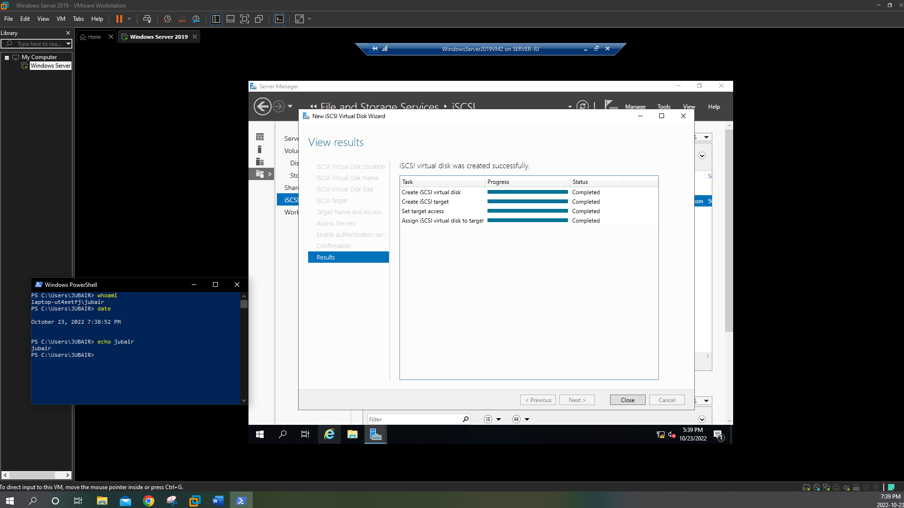

1. At the View results page, click **Close**. Note that E:\iSCSIVirtualDisks\iSCSI Virtual Disk

vhdx is shown in the iSCSI VIRTUAL DISKS pane, and that iscsitarget1 is shown in the iSCSI TARGETS pane.

1. Close Server Manager.
2. In Server Manager on your Windows Server 2019 host, click the **Tools** menu and then click **iSCSI Initiator**.
3. When prompted to start the Microsoft iSCSI service and configure it to start at boot time, click **Yes**.
4. At the iSCSI Initiator Properties window, type the IP address of your WindowsServer2019VM2 virtual machine in the Target text box and click **Quick Connect**.
5. Click **Done** to close the Quick Connect window.
6. Highlight the **Volumes and Devices** tab in the iSCSI Initiator Properties window, click **Auto Configure**, and then click **OK**.
7. Right-click **Start** on your Windows Server 2019 host and click **Disk Management**. Note that a new 50 GB storage device has been added and called Disk 1.
8. Right-click **Disk 1** and click **Online**.
9. Right-click **Disk 1** and click **Initialize Disk**. Note the default options that will place an MBR on Disk 1 and click **OK**.
10. Right-click the **50.00 GB Unallocated** space next to Disk 1 and click **New Simple Volume**.
11. At the New Simple Volume wizard, click **Next**.
12. At the Specify Volume Size page, click **Next.**
13. At the Assign Drive Letter or Path page, note the default E: drive letter assignment and click **Next.**
14. At the Format Partition page, note the default NTFS formatting options, type **Remote iSCSI Volume 1** in the Volume label text box, and click **Next**.

**(Take Screenshot)**

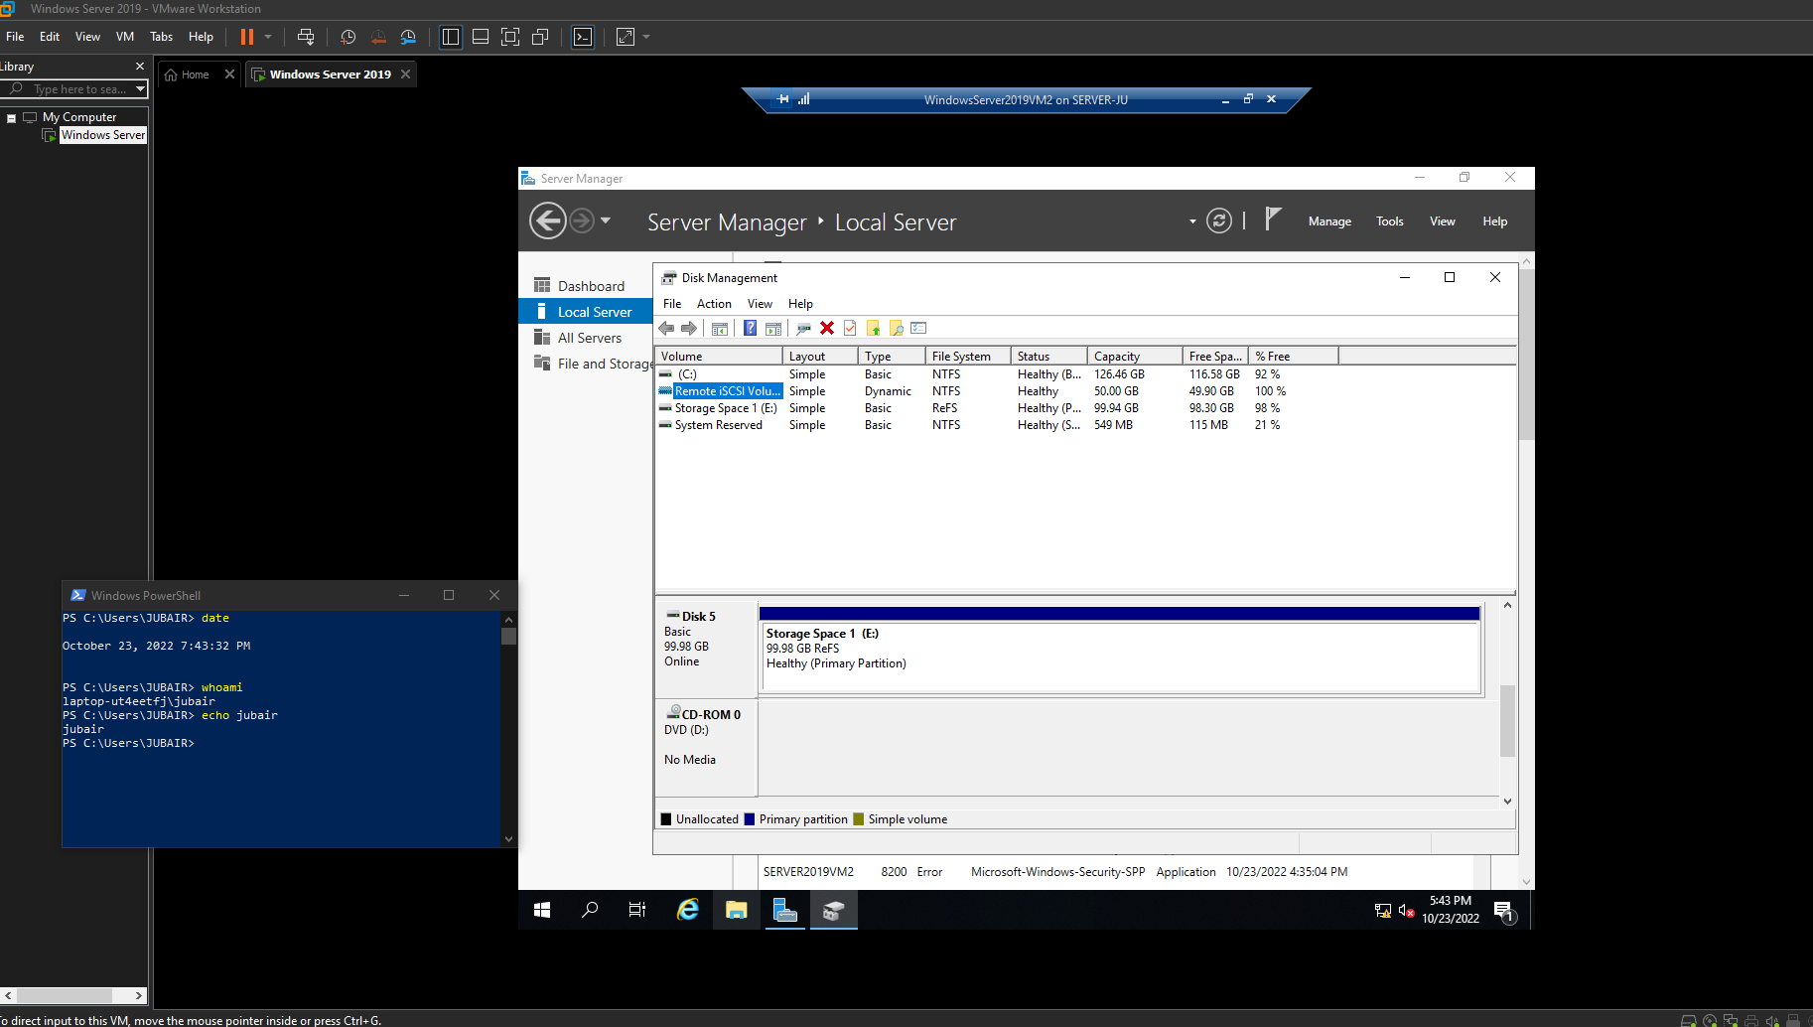

1. Click **Finish** to complete your configuration.
2. Close Disk Management.
3. Click **Start** on your Windows Server 2019 host and then click **File Explorer**.
4. In File Explorer, highlight **This PC** in the navigation pane and note that the Remote iSCSI Volume 1 (E:) lists the space available on the remote iSCSI storage.
5. Double-click **Remote iSCSI Volume 1 (E:).** Next, right-click the file pane in File Explorer, click **New, Text Document**, and press **Enter** to accept the default file name of New Text Document.txt.
6. Double-click **New Text Document.txt** to open it in Notepad. Type a line of your choice. Click the **File** menu and click **Save**. Close Notepad when finished.
7. Close File Explorer.

**Project 6: Managing Volume Data**

*In this Hands-On Project, you install and configure data deduplication for the E: volume on your WindowsServer2019VM2 virtual machine. Next, you optimize and scan volumes for errors on your WindowsServer2019VM2 virtual machine.*

1. In Server Manager on your WindowsServer2019VM2 virtual machine, click the **Manage** menu and then click **Add Roles and Features**.
2. At the Select installation type page, click **Next**.
3. At the Select destination server page, click **Next**.
4. At the Select server roles page, expand **File and Storage Services**, and then expand **File and iSCSI Services**. Select **Data Deduplication** and click **Next**.
5. At the Select features page, click **Next.**
6. At the Confirm installation selections page, click **Install.**
7. At the Installation progress page, click **Close**.
8. In Server Manager, highlight **File and Storage Services**, and then highlight **Disks** under the Volumes section.
9. Highlight **Virtual Disk 1** in the DISKS pane.
10. Right-click **E:** in the VOLUMES pane and click **Configure Data Deduplication**.
11. At the Storage Space 1 (E:) Deduplication Settings window, select **General purpose file server** from the Data duplication drop-down box.
12. Type **5** in the Deduplicate files older than (in days) text box.
13. Click **Add.** Expand **Storage Space 1 (E:),** highlight **iscsivirtualdisks**, and click **Select** **Folder** to exclude the contents of the iscsivirtualdisks folder from data deduplication.
14. Click **Set Deduplication Schedule** and note the default options. Select **Enable throughput optimization** and click **OK**.

**(Take Screenshot)**

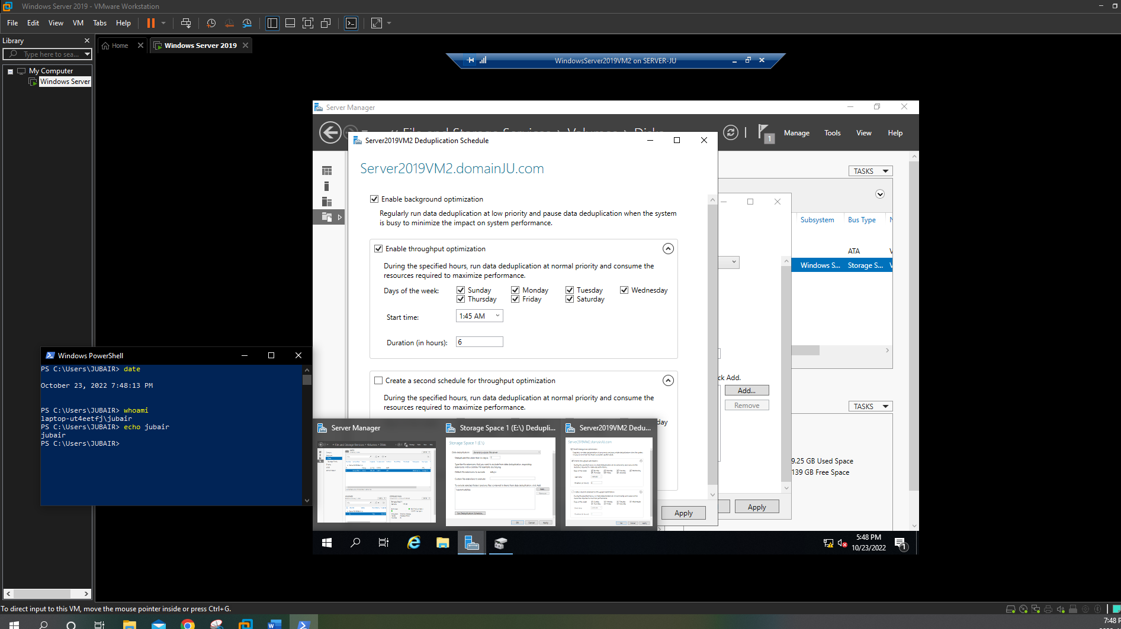

1. Click OK to close the Storage Space 1 (E:) Deduplication Settings window.
2. Right-click **E:** in the VOLUMES pane and note that the Scan File System for Errors option is unavailable because the filesystem on E: is ReFS.
3. Highlight **0** (Disk 0) in the DISKS pane.
4. Right-click **C:** in the VOLUMES pane, click **Scan File System for Errors**, and then click **Scan Now**. If the process completes with errors found, right-click **C:** in the VOLUMES pane, click **Repair File System Errors**, and then click **Repair Now**.
5. Right-click **Start** and click **Windows PowerShell (Admin).**
6. Type **chkdsk** and press **Enter** to check the filesystem on C: for errors.
7. Type **E:** and press **Enter** to switch to the E: filesystem provider.
8. Type **chkdsk** and press **Enter**. Note the message displayed.

**(Take Screenshot)**

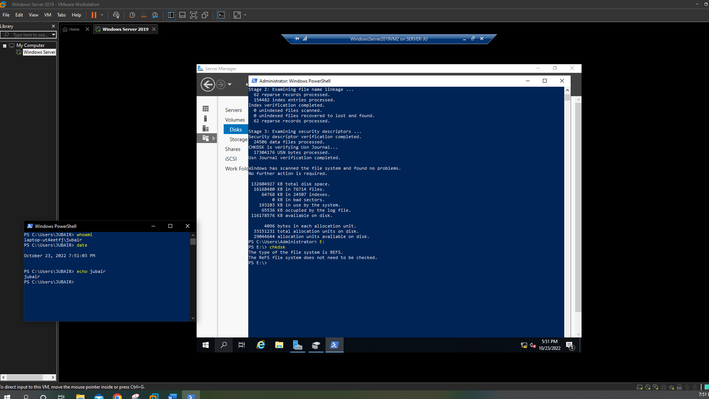

1. Close Windows PowerShell.
2. Click **Start** and then click **File Explorer**.
3. In File Explorer, highlight **This PC** in the navigation pane.
4. Right-click **Local Disk (C:),** click **Properties**, and highlight the **Tools** tab.
5. Click **Check** and then click **Scan drive**. After the scan has completed, click **Close**.
6. Click **Optimize** and note that weekly optimization is automatically scheduled. Click **Analyze** to analyze your C: volume for optimization. Next, highlight **Storage Space 1 (E:)** and click **Analyze** to analyze your E: volume for optimization. Click **Close** when finished.
7. Click **OK**.
8. Right-click **Storage Space 1 (E:),** click **Properties**, and highlight the **Tools** tab.
9. Click **Check**, note the message displayed, and click **Close**.
10. Click **OK** and then close File Explorer.

**Project 7: Backup and Restore**

*In this Hands-On Project, you install the Windows Server Backup feature on your Windows Server 2019 host. Next, you schedule a backup of the C:\MarketingMaterials and C:\MarketingTemplates folders, perform the scheduled backup immediately, as well as restore the backup that was created. Finally, you remove your scheduled backup from the system.*

1. In Server Manager on your Windows Server 2019 host, click the **Manage** menu and then click **Add Roles and Features**.
2. At the Select installation type page, click **Next**.
3. At the Select destination server page, click **Next**.
4. At the Select server roles page, click **Next**.
5. At the Select features page, select **Windows Server Backup** and click **Next**.
6. At the Confirm installation selections page, click **Install**.
7. At the Installation progress page, click **Close**.
8. In Server Manager, click the **Tools** menu and then click **Windows Server Backup**.
9. In the navigation pane of the Windows Server Backup tool, highlight **Local Backup** and then click **Backup Schedule** in the Actions pane.
10. At the Getting Started page of the Backup Schedule Wizard, click **Next**.
11. At the Select Backup Configuration page, select **Custom** and click **Next**.
12. At the Select Items for Backup page, click **Add Items**, expand **Local Disk (C:),** select **MarketingMaterials** and **MarketingTemplates**, and click **OK**. Next, click **Advanced** **Settings**, highlight the **VSS Settings** tab, select **VSS full Backup,** and click **OK**. Click **Next**.
13. At the Specify Backup Time page, select **11:30 PM** from the Select time of day **drop-down** box and click **Next**.
14. At the Specify Destination Type page, select **Back up to a volume** and click **Next**.
15. At the Select Destination Volume page, click **Add**, highlight **iSCSI Remote Volume 1 (E:),** and click **OK**. Click **Next**.
16. At the Confirmation page, click **Finish**.

**(Take Screenshot)**

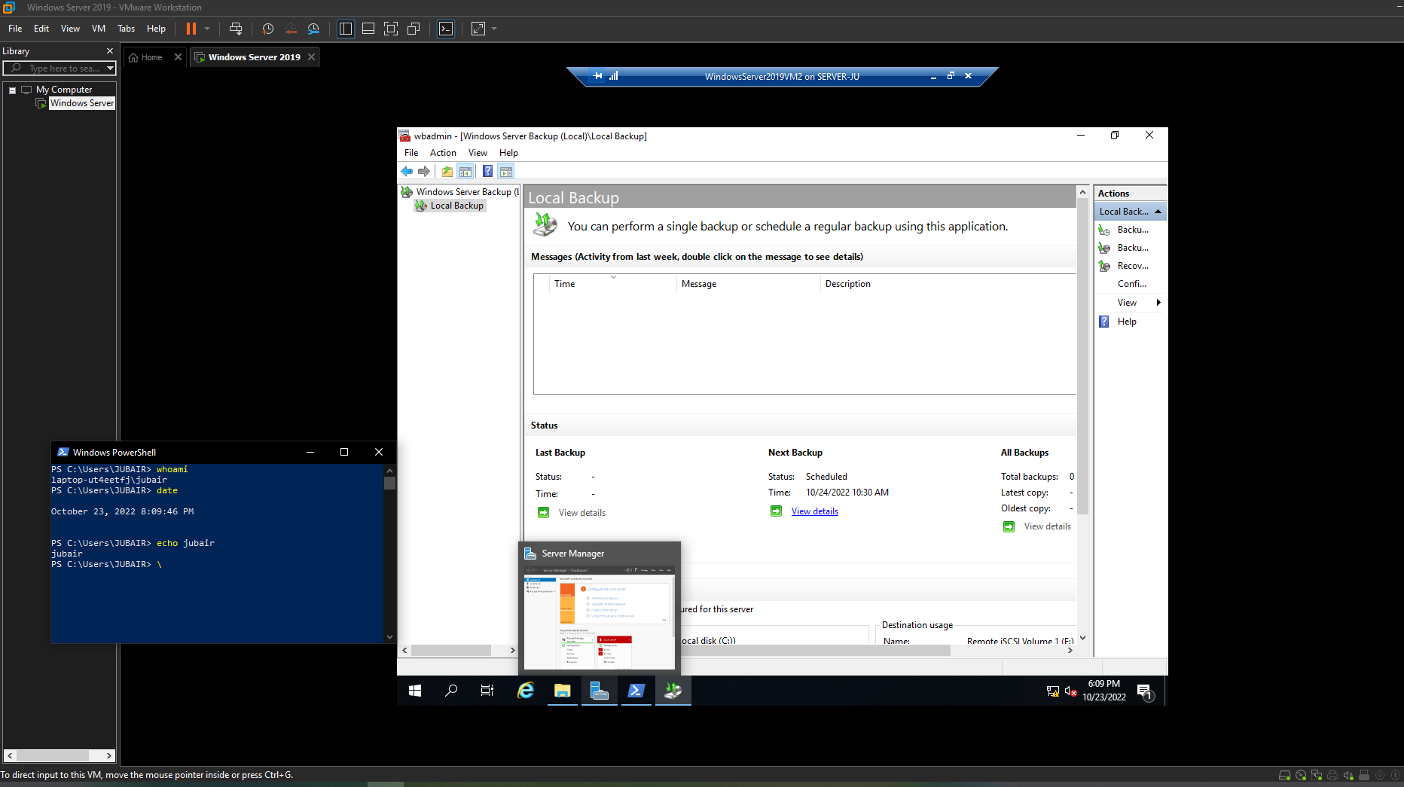

1. At the Summary page, click **Close**.
2. In the Actions pane of the Windows Server Backup tool, click **Configure Performance**. Note that the default Normal backup performance option performs full backups of all files and click **OK**.
3. In the Actions pane of the Windows Server Backup tool, click **Backup Once**.
4. At the Backup Options page of the Backup Once Wizard, click **Next**.
5. At the Confirmation page, note the backup options shown for your scheduled backup and click **Backup**.
6. After the backup has completed, click **Close**.
7. In the Actions pane of the Windows Server Backup tool, click **Recover**.
8. At the Getting Started page of the Recovery Wizard, click **Next**.
9. At the Select Backup Date page, note that your recent backup is selected by default and click **Next**.
10. At the Select Recovery Type page, note that only files and folders in the backup will be restored by default and click **Next**.
11. At the Select Items to Recover page, expand **serverX**, and then select **Local Disk (C:).** Note that MarketingMaterials and MarketingTemplates are selected and click **Next**.
12. At the Specify Recovery Options page, note the default options. Select **Overwrite the existing versions with the recovered versions** and click **Next**.
13. At the Confirmation page, click **Recover**.

**(Take Screenshot)**

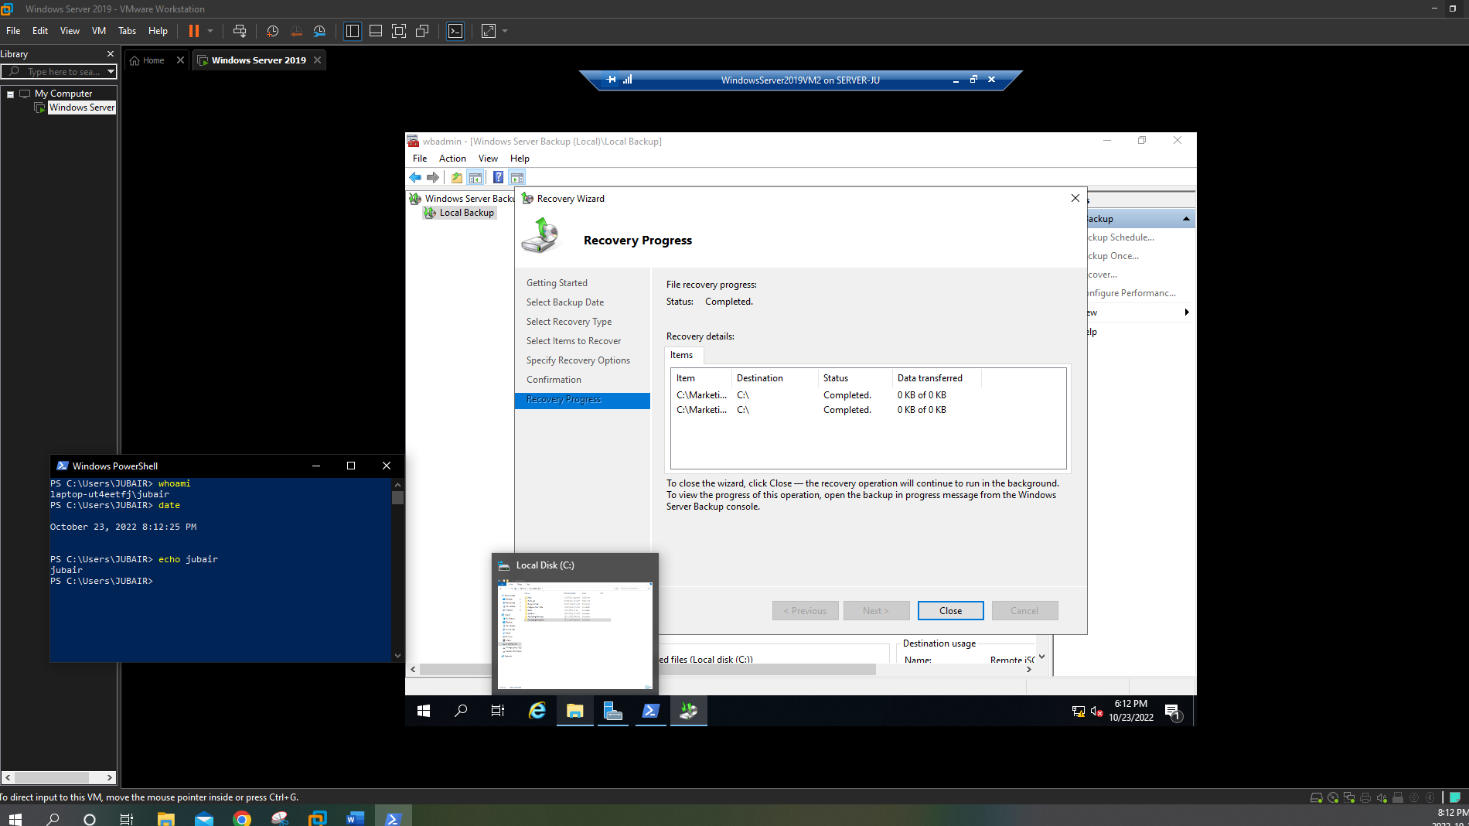

1. At the Recovery Progress page, click **Close** after the folders have been restored.
2. In the Actions pane of the Windows Server Backup tool, click **Backup Schedule**.
3. At the Modify Scheduled Backup page of the Backup Schedule Wizard, select **Stop** **backup** and click **Next**.
4. At the Confirmation page, click **Finish**.
5. At the Summary page, click **Close**.
6. Close Windows Server Backup.